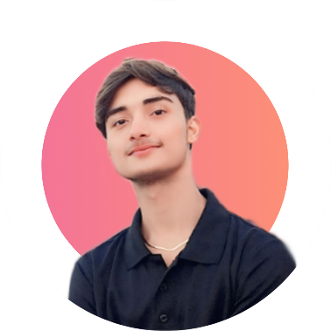
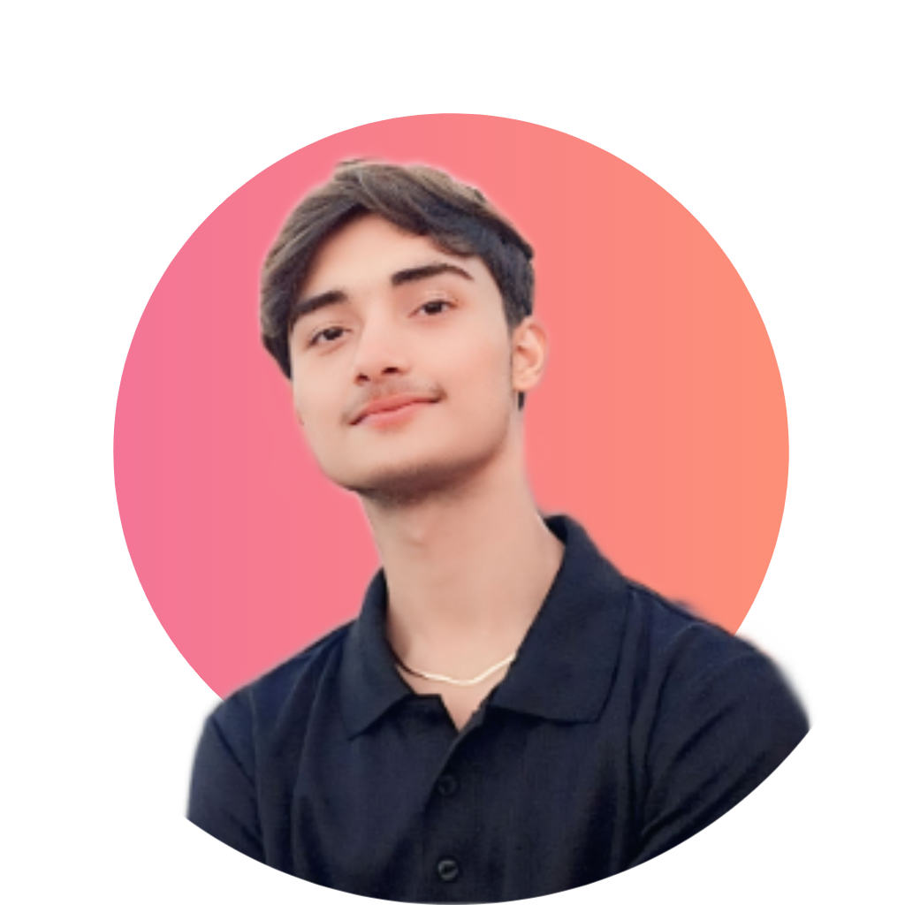
SOCIAL LINKS
- FRONT END DEVELOPER
- BACKEND DEVELOPER
- MERN STACK DEVELOPER
- HTML, CSS, JAVA, REACTJS, ANGULAR

- MATRIC FROM TCF
- FRIST YEAR (AWATING FOR RESULT)

SKILLS:
EDUCATION

📞 03222301920
https://devkabeer.vercel.app/
📧 kabeerai9090@gmail.com
https://devkabeer.vercel.app/
🌐 https://devkabeer.vercel.app/
https://devkabeer.vercel.app/
Video provides a powerful way the video that best fits your document. Video provides a powerful way the video that best fits your document.

ABOUT

MERN STACK DEVELOPER

_____________________________________________________
MUHAMMAD KABEER

